The method to silencing trouble beeps depends entirely on the alarm system you’re using. Below are pictures of the keypads from our most common security systems, look below to find your keypad and follow the instructions listed. If your alarm keypad does not look like any of the ones below please contact us for further assistance.
Business Hours: 800-949-1799 (Monday-Friday 8a-4:30p)
After Hours: 800-432-1429 (Central Station)
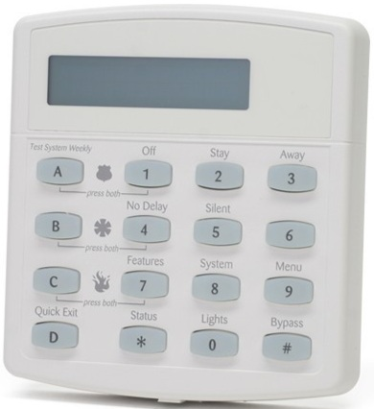
Concord Series Panel

- Make sure your security system is disarmed, which can be accomplished by pressing 1 + 4 digit keypad code. Your panel may have a key labeled disarm, or off, these will also work in place of 1.
- Press the asterisk button once at the bottom left of the keypad, labelled “Status”. The alarm will display what troubles are currently occurring and will also try to reset it.
- If you’ve lost power or have a low battery condition, the trouble condition will not clear by itself until the issue is resolved. Once power is restored to the home you will have to reset the system once more by pressing the status button.
Simon XT Series Panel
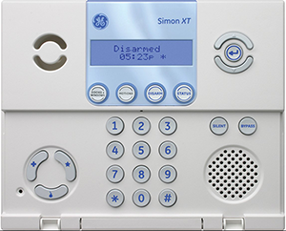
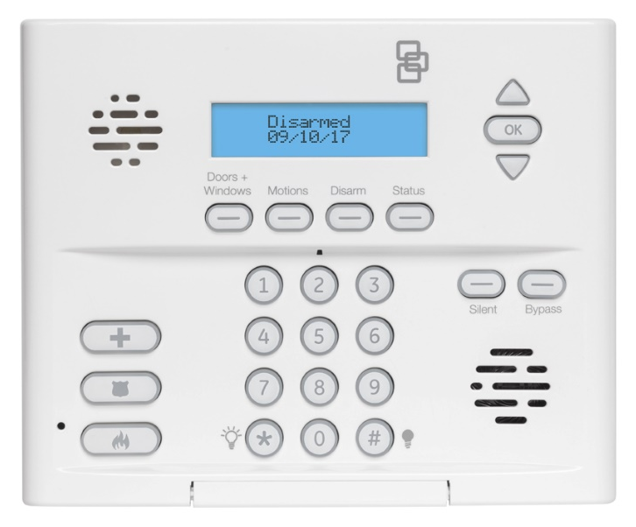

- Make sure your security system is disarmed, which can be accomplished by viewing the screen and seeing if it says “Disarmed”. If the panel is not disarmed, disarm it by pressing the disarm key located beneath the display and then immediately enter your 4 digit keypad code.
- Press the status button located at the bottom right of the display, the keypad will announce all current and past troubles or alarms that are in its memory. To clear all past troubles press status again and then immediately afterwards press disarm located directly to the left of the status button.
- Press the status button again and the keypad will announce “System is Okay” if there are no troubles, otherwise it will announce whatever troubles are currently existing that it could not clear.
- If you’ve lost power or have a low battery condition, the trouble condition will not clear by itself until the issue is resolved. Once power is restored to the home you will have to reset the system once more by pressing the status button.

DSC PowerSeries Neo Panel
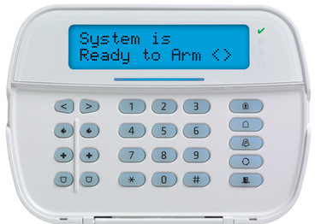

- Make sure your security system is disarmed. If the system is currently armed there will be an LED illuminated to the right of the screen in the shape of a padlock. If this LED is on, your system is armed and you will need to disarm it by entering your 4 digit keypad code. If the padlock LED is not illuminated this means your system is already disarmed.
- Press * 2 on the keypad and it will display what troubles are active, press * again to view further details. To clear and silence the beeps press # twice to go back to the main screen.
- All trouble conditions will clear automatically once the issue has been resolved.

Qolsys IQ Panel 2
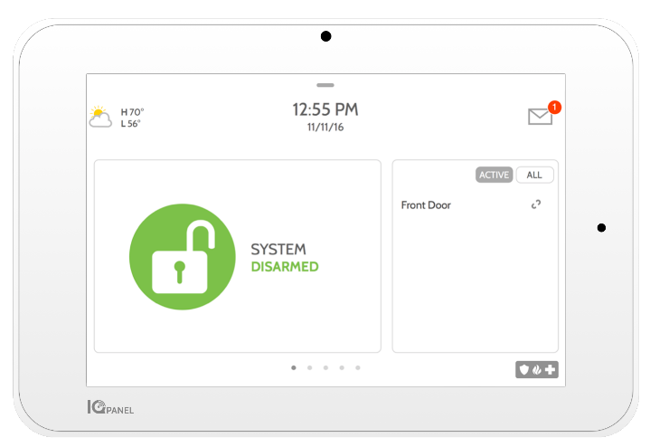
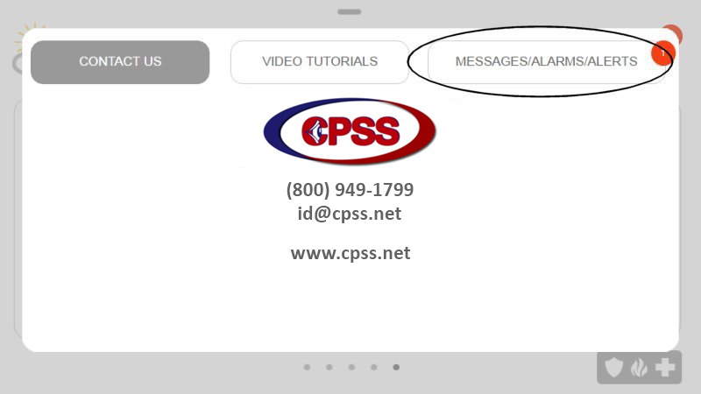
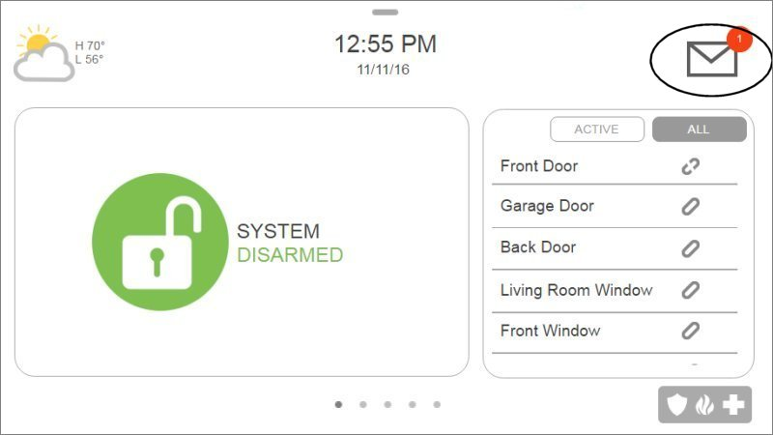
- Press top right Message icon then press Messages/Alerts/Alarms

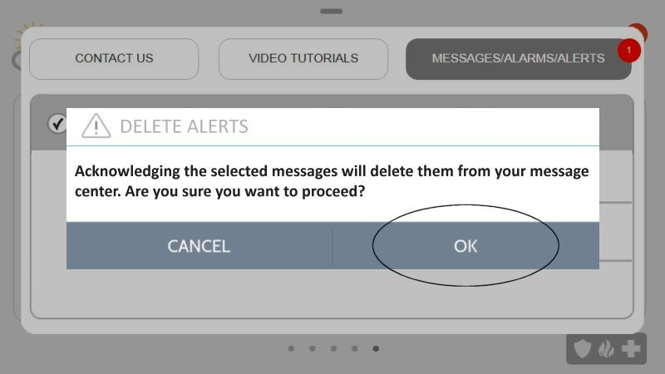
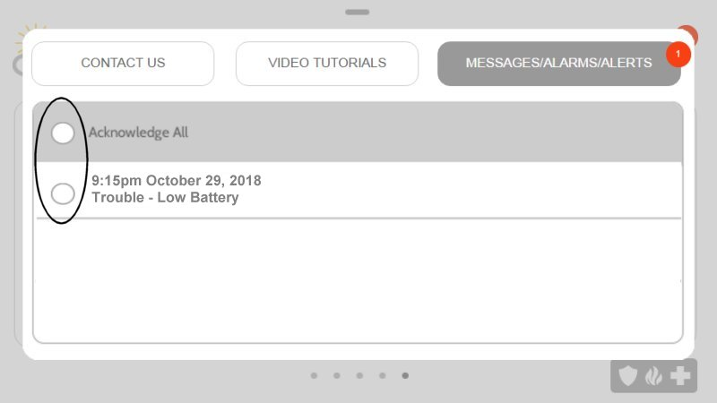
- Press Acknowledge All to select all alerts then press OK

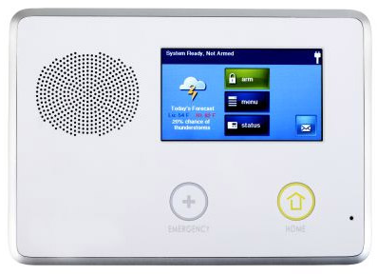
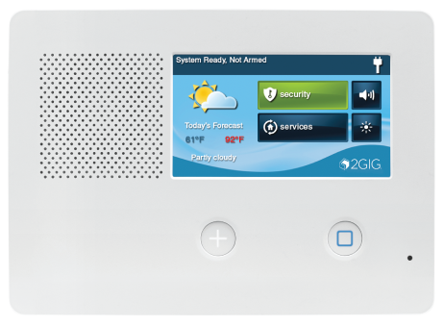
2GIG GC2 & GC2e

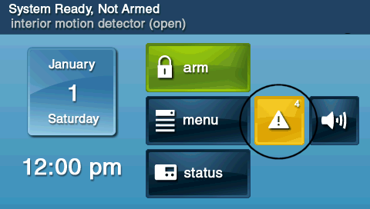
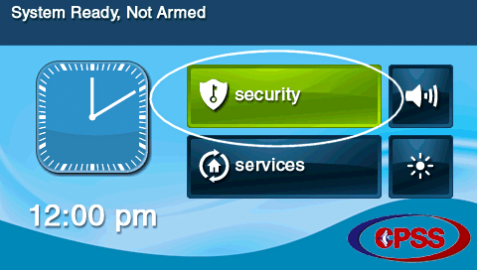
- Press Security then tap the yellow triangle button.

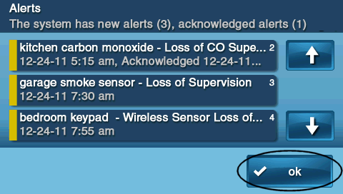
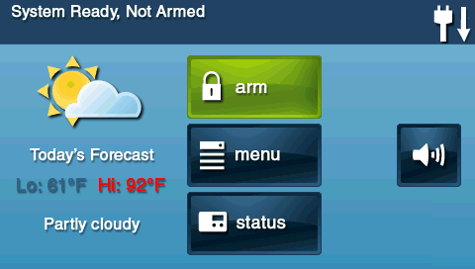
- Use the up/down arrows to scroll through the alerts to clear them, then press Ok to exit. This action will silence the beeping for 4 hours, but the issue must be resolved in order for beeping to completely end, and clear alerts for issues that have been resolved.

See next page for further details on the GC2 & GC2e

2GIG GC2 & GC2e (Continued)

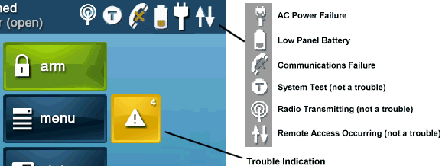
- The top bar on the main screen can also indicate various alerts.

- Trouble Alert Descriptions:
  - AC power failure: check the power outlet to which the panel is connected. Confirm the transformer is securely connected.
  - Low panel battery: If power has been interrupted, allow 24 hours for the panel battery to recharge. If this persists, look into replacing the battery.
  - Communication failure: has there been a recent change to your WiFi? Ensure the panel is updated with sign in credentials. Also, look for any new source of interference.
  - For other trouble conditions, please refer to your user or installation manual.
2GIG Edge
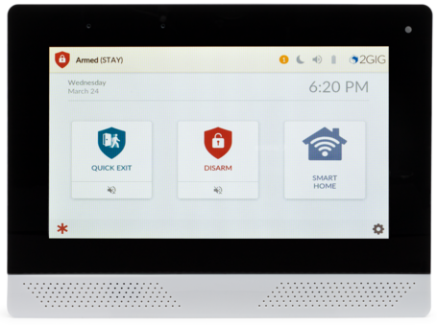
- If there are unacknowledged trouble conditions, the header bar flashes orange and a numeric icon will display how many unacknowledged conditions exist. Tap the numeric icon, then tap “Alerts” to view the trouble conditions.
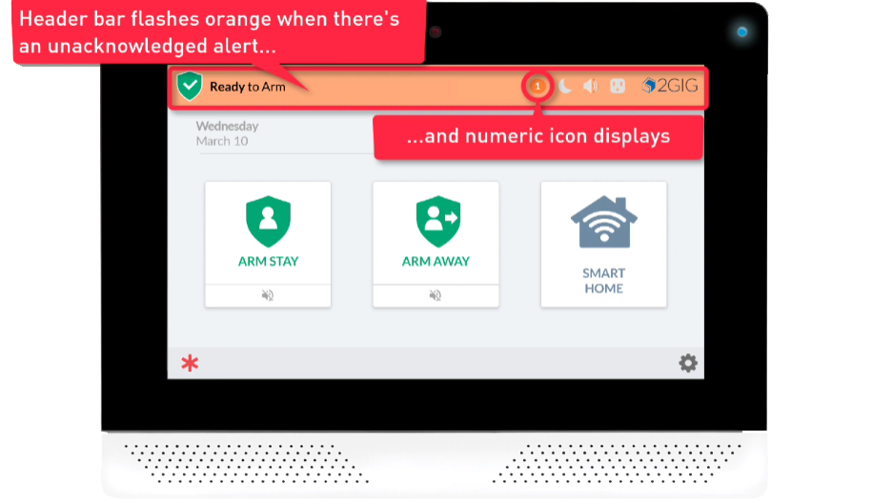

See next page for further details on the Edge Panel
2GIG Edge (Continued)
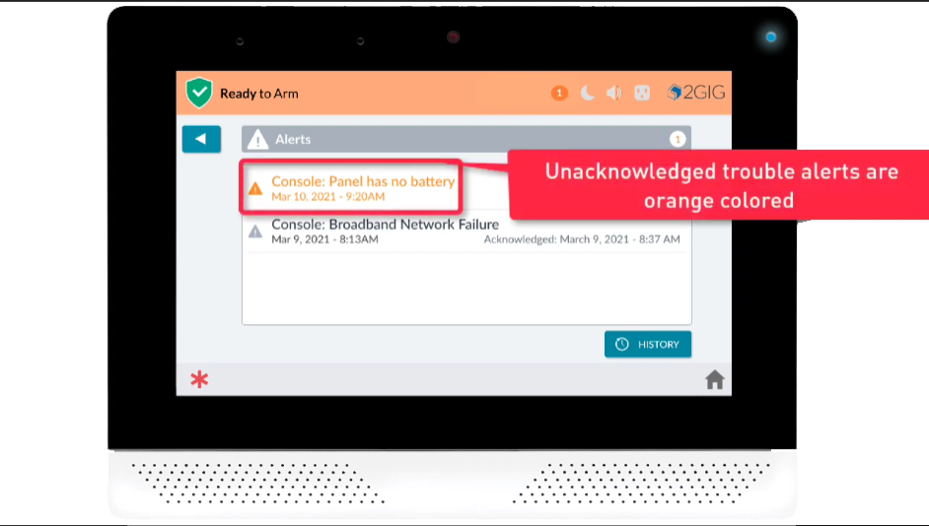
- The screen that appears next will display all past and current trouble conditions. New and unacknowledged trouble conditions will have their text colored orange, previous conditions will have grey colored text.

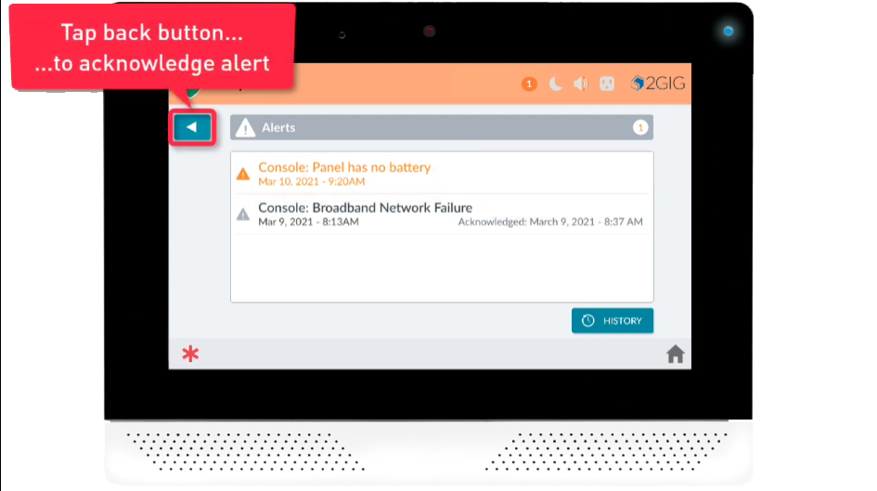
- Tap the back button to acknowledge the alerts and the panel will stop beeping. Please note that if the issues continue after more than a few hours the alarm panel will start beeping again. If this occurs just repeat the above steps.

